Flipped classroom with associated workbook, video blogs and an inter-seminar group quiz to apply knowledge.

1. Used a flipped classroom approach to teaching mathematical concepts around drug dosage calculations, producing a workbook and associated video blogs to facilitate learning.

2. Stage 1 MBBS (medicine) students (~210)

3. The session was a one hour ‘Drug Calculations’ session. Doses of drug may be expressed in a number of different ways (e.g. ratio strength, percentage strength) and students need to understand these expressions and be able to convert between them to calculate drug dosages. I approached this session with a number of different teaching techniques. Firstly I changed the one lecture slot into four lecture slots, splitting the year of 12 seminar groups (~18 students per group) down into classes of 3 seminar groups at a time. This was to try to increase the amount interaction I could have with the students and to make it easier for them to ask questions, as they may have felt intimidated to do so in a lecture theatre of ~215.

I wrote a 14 page workbook which clearly explained all the forms of dosage and concentration calculations they would have to learn. I provided worked examples and then I wrote a series of increasingly difficult questions for them to complete before their face to face session with me. The answers were provided in advance of this session for students to check that they had understood and correctly completed the questions. I provided the answers in two formats; a fully completed workbook and also video recordings of me completing the workbook while talking through how I am approaching the questions as I did the calculations (see figure which is a screen shot from one of the videos).

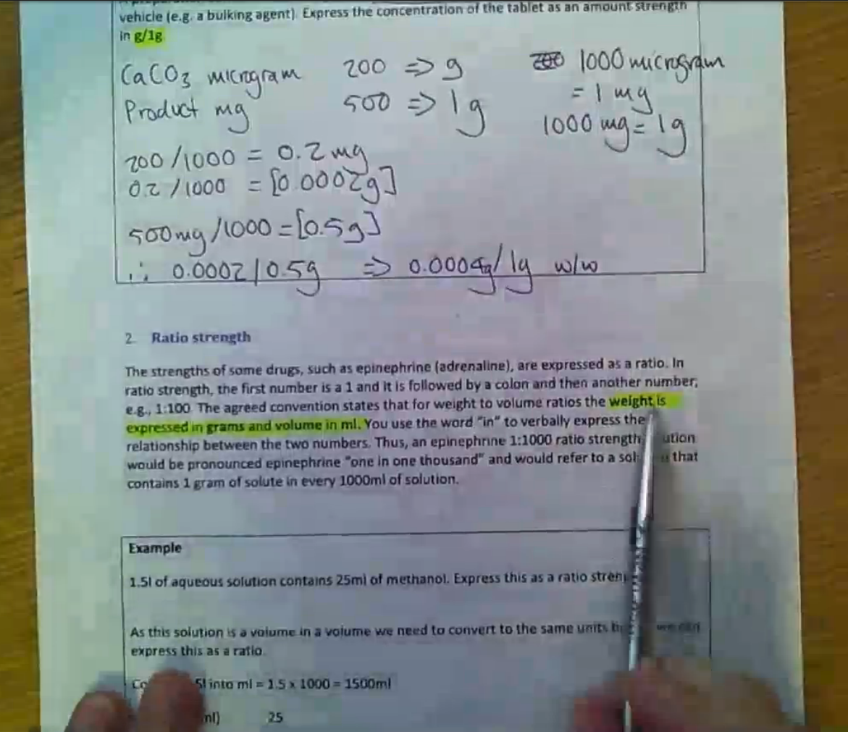

I used the hour session with the students to get them to apply the knowledge they had learned beforehand to a series of clinically based questions in class. I ran the sessions as an inter-seminar group quiz using TurningPoint. TurningPoint allows you to split the students into different groups who then compete against each other, adding an element of competition to the session. You can also use TurningPoint functions to assess which particular student has performed the best, who has answered the questions the quickest etc. I gave pens as prizes to the best performing students.

4. I took the flipped classroom approach because each student starts off with different levels of proficiency in maths. If I tackled the subject in a traditional lecture format and pitched it to the students who struggled most with maths (to ensure the whole class understands the calculations) then the more able students would be bored and disengaged as it would be too easy. Also it’s quite a dry subject to teach. Each student learns how to do calculations in their own way and at their own speed. By providing them with a workbook which takes them step by step through how to do the different calculations, then providing a series of increasingly difficult questions for them to work through, the students can learn at their own pace. The answers were provided in two formats. A fully completed workbook was uploaded onto the VLE. This completed workbook showed the working out for each question detailed step by step. However, this year I also produced the video recordings of me completing the workbook while talking through how I am approaching the questions as I did the calculations. I did this to model metacognition, which will help students to understand (through my spoken example) the thought process behind approaching the different calculations.

I believe that once you have learned the basics about how to perform a particular mathematical calculation, the best mode of learning is to then practice. Students learn the theory and the basics in advance of the class then work to apply this theory to a series of clinically based questions in class. I also ask the students to write at least one drug calculation question of their own and upload it to the associated PeerWise course online (PeerWise is a free online quizzing platform, which I have set up all our MBBS courses on, that allows the students to author and answer MCQs, rate the quality of other students’ contributions as well as discuss content – see a subsequent case study). In this way the students work together to build a further bank of practice ‘drug calculations’ questions.

5. Students have responded very positively to the flipped classroom and workbook approach. The following excerpts are from EvaSys evaluation of the session.

“I really enjoyed the 'flipped classroom' approach to the drug calculations lecture, as this allowed us to work at our own pace to get a full understanding of the content and then quiz ourselves during the lecture to practice our methods. This seems like a much more effective use of our lecture time.”

“The interactive seminar group quiz session (CPTP1.5) was great fun as well as very useful.”

“The practical maths session was really helpful, defiantly being split up into smaller groups.”

“Workbook allowed us to work through the calculations and apply the concepts in our own time”

“Drugs calculations workbook had lots of worked examples which allowed me to go away and work on it myself so I was prepared to get more out of the calculations seminar. Lectures were always interesting because of lecturer's innovative techniques of asking for classroom participation”

“The maths booklet was fantastic: I approached with fear as I did not do well the calculations in the November exam, and I felt that I was not going to be able to do it. However, it was explained without assuming any prior knowledge, and it enabled me not only to grasp all the concepts without problems, but also to successfully complete the exercise in advance.”

